Module 1 Real Data Project Answer Sheet Name _________________________________________

- Perform the following operations on Data Set I.
- Type of data: ________________________ Level of measurement:_________________
- Use table below:
No. of Deaths | Frequency | Cum. Freq. | Rel. Freq. | Midpoints | Boundaries

- Use the table in Part C to construct a:
1.
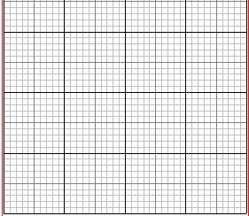

2.
Shape of Graph: ___________________________
- Use your calculator:
1. Mean = ___________________
2. Standard Deviation = ___________________
3. Median = ___________________
4. First Quartile = ___________________
5. Third Quartile = ___________________
- Use the values from Part E to
1.
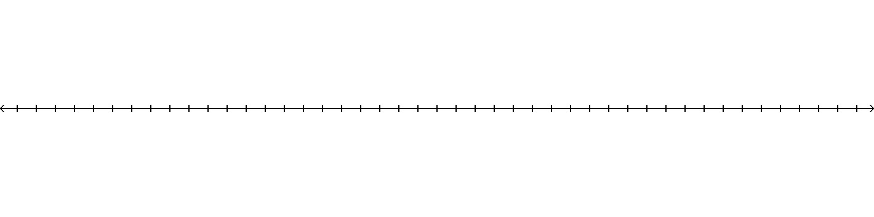
2. Outliers: __________ Justification _____________________________________
- Best measure of center: ______________________ Why? ________________________
- Perform the following operations on Data Set II.
- Type of data: ________________________ Level of measurement:_________________
- Make a table of the data and their frequencies (you can group some together)
Activities | Frequency

- Use the table in Part B to construct a:
1. Pareto graph

2. Circle graph

- Mode = ____________________

- Perform the following operations on Data Set III.
- Type of data: ________________________ Level of measurement:_________________
- Use table below:
Year | No. of attacks | Year | No. of attacks | Year | No. of attacks

- Construct a frequency table of the number of shark attacks each year.
No. of attacks | Frequency
0
1
2
3
4
5
6
7

- Use the table in Part C to construct
Shape of Graph: ___________________________
- Use your calculator:
1. Mean = ___________________
2. Standard Deviation = ___________________
3. Median = ___________________
4. First Quartile = ___________________
5. Third Quartile = ___________________
- Use the values from Part E to
1.
2. Outliers: __________ Justification _____________________________________
- Best measure of center: ______________________ Why? _______________________
Neatness: _____________

